Adrian Perez Rosado & Lucas Kizirian Rangel

Professor David Stendel | COP 2822C Web Site Development CRN: 15999

Valencia College

11/09/2023

**Crack N’ Fix**

Repairing It Right, One Fix at A Time

**Crack N’ Fix**

# **Goals and Purpose**

The primary goal of the Crack N’ Fix website is to provide a user-friendly online platform for individuals seeking electronic device repair services. The website aims to offer the following:

Information: Provide detailed information about the services offered, the repair process, pricing, and the company's expertise in repairing modern electronic devices.

Online Interaction: Allow customers to submit repair requests, upload device information, and schedule appointments online.

Transparency: Present an easily navigable website that instills trust in potential customers by displaying past work through a gallery, repair guides, and helpful FAQs.

Accessibility: Ensure the website is accessible to a broad audience, including visually impaired users, through a text-based navigation alternative.

# **Audience**

The target audience for the Crack N’ Fix website is individuals who own electronic devices that require repair. The website should be designed to appeal to people of all ages and backgrounds, with an emphasis on ease of use and accessibility.

# **Design Requirements**

The Crack N’ Fix website should have a clean, modern design that is easy to navigate. The color scheme should be simple and maintain consistent layout, font styles, and color schemes throughout the site. The website should be optimized for mobile devices, with a responsive design that adapts to different screen sizes.

# **Delivery Requirements**

The website should be delivered in HTML, CSS, and JavaScript. The code should be well-documented and easy to maintain. The website should be hosted on a reliable server with fast load times. The website should also display correctly on modern browsers and operating systems.

# **Content**

The website will consist of the following pages, each with specific content:

Home: The homepage will introduce the Crack N’ Fix brand, display featured services, and provide quick links to essential information.

About: This page will detail the company's history, values, and mission, establishing trust and credibility.

Send Us Your Device: This page will contain an online form to submit repair requests, including device details, scheduling preferences, and pictures of the device.

Device Repair Guides: This page will contain repair guides, tips, information for DIY and tech-savvy visitors.

Gallery: A gallery of before-and-after images of repaired devices and previous repairs done.

Help and FAQ: Frequently asked questions, troubleshooting tips, and contact information for customer support.

Contact: This page will provide contact information, including an email address and phone number, for users to reach out for inquiries or support. As well as physical store address and map location.

*At the footer of the page you will find quick links for webpages and other information about the business, like contact information, business hours, social media links, address, and map location.

# **Flowchart**

https://wireframe.cc/v50lug

Here is a flowchart illustrating the navigation between the website pages:

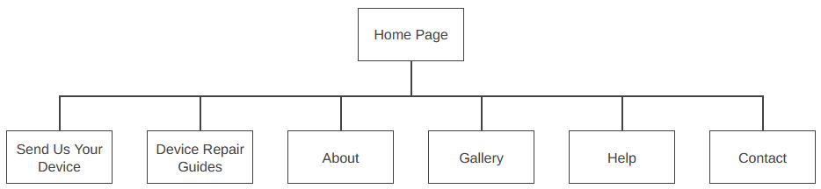

Home

**Crack N’ Fix**